DISCIPLINES: Cave and Karst Science

From the foundation of ASF there has been a symbiotic relationship between those with interests tending to the scientific and those with a largely recreational interest in caves: caves cannot be studied or managed until they are discovered and surveyed. On remote-area expeditions in particular these have often taken place simultaneously. Most results from scientific work in Australian caves are published in Helictite or other similar journals and many preliminary studies have first appeared in Proceedings of the ASF Conferences. The Newsletter has been used as a medium mostly to assist cavers in related investigations, to alert readers to recent scientific work, and to sharpen their skills of observation and interpretation.

A TROPICAL PHENOMENON?

Norman Poulter

Caves Australia 163 (2004)

Following the 22nd ASF Conference in Rockhampton in early 1999, I was fortunate enough to be taken to "The Cave With The Thing That Went Thump" (E-5), a cave known more for its name than anything it contained. Just inside, I encountered a most unusual stalagmite decoration. It was not so much the stalagmite itself which was only about 300mm high which attracted my attention, rather the unique calcite "growth" at the top. The stalagmite was fed by quite rapid dripping just off the centreline of the decoration which had created an intricate "boxwork" pattern of micro-heligmites. There was much speculation at the time, as to what dynamics led to the formation of this incredible feature.

A few days later, I was back to photograph the feature in company with Angus Macoun (RSS), Mary McCabe, Dianne Vavryn and Nathan Berrill (CQSS). Several hours and rolls of film later, we struggled back through mosquito-infested foliage and encroaching darkness, to the vehicles. I was quite pleased with the results of some of the photographs. Angus was not so lucky, he had been using extension rings and suffered severe splashing on his lens whereas I had been using a bellows and bellows lens from a "stand-off" position, well out of the splash range.

During a trip to the Kimberley Ranges earlier this year, I was on a short trip (arranged for us by John Cugley (WASG)) to caves of the Ningbing Range, just north of Kununurra (I had visited the region twice before). The last cave visited was Nice Cave (6KNI-50), so named by the husband and wife team who discovered it, finding it was "nice" to get inside from the oppressive heat outside - the mere fact that the cave ultimately revealed nice decoration too, was a pleasant bonus.

Anyway, to cut a long story short, while photographing some of the cave's charms, I came across a stubby stalagmite with a striking similarity to the top of the stalagmite of "The Cave With The Thing That Went Thump". Although slightly further from the entrance and much lower to the ground than the 4E-5 feature, it was still forming under much the same circumstances i.e. rapid dripping.

Just how does it form? Is this type of decoration unique to the tropical regions or can it form under the same rapid dripping conditions anywhere in Australia - or the world for that matter?

I would like to close with a plug for East Kimberley caving. John Cugley could do with some help documenting the caves in this remote corner of Australia where the discovery of new and significant caves is virtually guaranteed - three were found during a morning's walk on our weekend jaunt during May. In some respects, the term "remote" is a bit of a misnomer, the Ningbing Range lies within 100km of Kununurra, the equally spectacular Jeremiah Hills are even closer to town - it's just that Kununurra is an awful long way from anywhere else. John can be contacted at PO Box 1845 Kununurra 6743. Winter is the most comfortable time to visit.

AQUATIC TROGLOBITES OF SOUTH AUSTRALIAN CAVES and SINKHOLES

Peter Horne

Australian Caver 111 (1986)

A considerable amount of cave research has involved the forms of life which are to be found in ‘dry’ cave environments, but until relatively recently, very few studies of ‘wet’ cave lifeforms had been undertaken in Australia.

Some workers long ago began recording the more obvious forms of life which were to be found in certain springs, ponds and open sinkholes (resulting in some instances in the discovery of rare or unique creatures as in Ewens and Picaninnie Ponds – Hallam and Lipson etc) but the first true troglobites to be found underwater in South Australia, a previously unknown species of crustacean was discovered and captured by this writer in January 1981 whilst engaging in recreational cave-diving near Mount Gambier, in the Lower South East.

The significance of this discovery was immediately obvious to the South Australian Museum’s Curator of Marine Invertebrates, Wolfgang Zeidler, who identified the centipede-like animal as a syncarid, and further studies showed that the specimens caught were well-adapted to cave environments having extra-long antennae, no eyes, and being found anywhere between the underwater twilight zone and the very deep regions of the dark zone. Previous discoveries of syncarids in Australia occurred many decades ago, in Victoria and Tasmania, where they were to be found in shallow surface pools and were not blind (pers. comm. W. Zeidler 1983). It is an interesting coincidence that the ‘type locality’ for the syncarids, L81 or “Fossil Cave” (also called the Green Waterhole) is also the sight of very significant fossil bone discoveries in recent years, where extinct species of kangaroo, cuckoos and Marsupial Lions, to name a few, were identified through their bones being carefully retrieved by cave divers (CDAA Occasional Paper #2, 1981).

Spurred on by this unexpected discovery our small group of interested divers began to spend much of our time collecting anything that moved underwater! Soon, we had found other unidentified life-forms, including molluscs, freshwater sponges (found mainly in the dark zone of two major sinkholes even beyond 40m depth), and more recently, blind amphipods. All of these specimens have now found their ways to the S.A. Museum for possible future study by interested parties.

Of interest is the fact that both syncarids and amphipods are frequently found in the same caves, usually those with very little pollution in the case of the larger cenotes or in shallow semi-permanent pools deep within the dark zones of some of the more common fissure-caves of the region. Productivity is evidently very low for all troglobites found underwater to date.

A cave which was unexpectedly found to contain blind(?) amphipods is NARRINA (F11) in the Flinders Ranges (Fig. 1) - not to be confused with NURINA, in the Nullarbor Plain, where amphipods have also been found recently (ASF Newsletter #101, 1983 p.3). A member of our underwater mapping party, Geoff Newman, took note of my somewhat casual comment to “look for anything that moved!” and to my amazement, discovered amphipods under a single decomposing bit of wood! This discovery in June 1984 is interesting in view of the fact that a much better equipped party had unsuccessfully explored this cave in 1978 specifically searching for underwater life-forms. The “nil sightings” of that trip prompted some to consider introducing fish into the cave to possibly observe ‘troglobitisation’ but fortunately, this was never done. This subsequent amphipod discovery proved that just because something isn’t readily visible in a cave doesn’t mean it isn’t there!

I sincerely hope that the cave diving community and the caving groups can work together to add to the steadily-growing speleological knowledge of our Australian caves – with more trained and interested people entering this field, there is promise of many great discoveries to come.
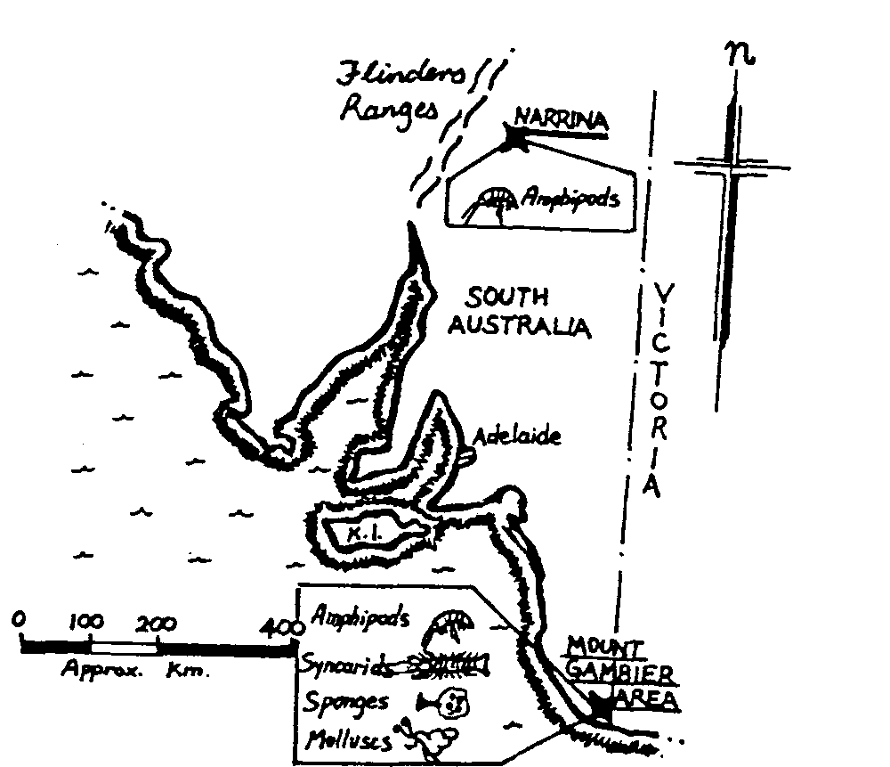

Figure 1 : location map of known sites of underwater troglobites of South Australia (to June 1985).

BATS, CAVES AND CAVERS

Belinda Cardinal

Cavers are constantly reminded of issues regarding the preservation of the cave environment. These are of vital importance and include issues such as touching formations or walking on flowstone, trampling of mudbanks, following marked paths and removing waste. Cavers are aware of these issues and generally attempt to minimise their impact. For many years it has been recognised that human presence inside caves containing bat roosts has a detrimental effect on the inhabitants, however this information and advice on impact minimisation has been slow to reach the practical caver. Most cavers will have encountered bats or will encounter bats at some point. Many cavers are aware of the problems and do take steps to minimise their impact. However, other cavers are not aware of the importance of this issue or are unsure of the correct way to approach the situation.

We must try to remember that we enter caves as visitors and we should respect them as valuable geological sites as well as the bats only available habitat. Without these sites, cave dwelling bats can no longer exist.

Approximately one third of Australias 75 bat species rely on caves. In south-eastern Australia, there are three species of cave dwelling bats which may be encountered. These are the Large bentwing bat, Eastern horseshoe bat and Large-footed myotis. In the southern regions, cave dwelling bats are more likely to spend the majority of the cooler months in torpor. Torpor is a state of lowered metabolic rate where body function slows and the bat cools down to conserve energy over the winter months when insect availability is reduced. During this time the bat survives on accumulated body fat from the previous autumn. Bats must wake from torpor from time to time in order to drink. For cave dwelling bats water is usually available from the cave roof or from condensation on the bats fur so the bat does not need to wake up completely. Waking from torpor requires the use of some of the bats stored energy. If the bat does need to fly in order to obtain water, more energy is used up. Bats usually pay for the cost of the flight by capturing insects on the wing. It is for this reason that bats are more likely to obtain their water on a mild night when insects are more likely to be available. Unnecessary arousal from torpor caused by disturbance from humans results in the bats using some stored energy. If they are woken during the day and therefore cannot leave the roost, they cannot replace the lost energy. Alternatively they may be woken on a cold night and unable to replace the lost energy since there are no insects available. The more often bats are woken from torpor, the more likely it is that they will not survive the winter. This aspect of bat biology should be a large consideration to any caver considering a trip during winter.

In northern regions of Australia, the number of species of cave dwelling bats sky-rockets. Due to the warmer weather in the north, the insect availability is higher and remains so year round. Unfortunately this does not mean that the bats are unaffected by disturbance. In all areas of Australia, disturbance of bats can easily lead to their leaving the safety of the roost. Bats are very active in warm conditions. Their agitation can be swift and if the disturbance is prolonged the bats will leave the roost, even in broad daylight, where they are easily caught by birds of prey such as falcons and currawongs. If the site is visited by people consistently it is possible that the bats will cease to use that site. Summer is the breeding season for cave-dwelling bats and they require very specific conditions for raising the young. This limits the available maternity sites (to only 5 in south-eastern Australia for bent-wings) and makes disturbance a real threat. Bats leaving a disturbed maternity roost may leave behind pups too young to fend for themselves.

Disturbance of bats does not require extreme behaviours. Sounds such as voices, walking through still water or the scrape of packs is enough. Light also causes disturbance. Disturbance of torpid bats is of most concern. If torpid bats are encountered unexpectedly, disturbance can be minimised by making as little noise as possible. This includes no talking, and moving very carefully through the cave, back towards the entrance. If the bats are in torpor, they will not wake immediately. This does not mean they haven't been disturbed. They are slowly bringing their body temperature up to a level at which they are capable of flying. If the disturbance is very minor and lasts only a very short time, the bat may not reach full alertness and return to torpor, thus saving some energy. It is therefore advised that lights are not shone onto the bats. The very worst thing that can be done to a torpid bat is to touch it as this will definitely result in arousal. In this situation it is best to leave immediately. In summer there is virtually no way that you can enter a bat roost without disturbing them.

Most caves have had the presence or absence of bats recorded in the past. These records may be old but it does provide a starting point or an expectation for that site. The best way to minimise impact on bats is to simply refrain from visiting bat roosts when bats are present, especially in the depths of winter or the maternity roosts in the height of summer.

However, it may be known that bats may roost only in certain parts of a cave which can be avoided. This sort of information is usually only discovered by cavers diligently recording where bats are roosting on trip reports which helps build up a picture of bats cave use.

If a roost is used year round and vital work must be carried out, this work could be done at night (during a warm period to reduce the effect of waking bats from torpor) when the bats have the opportunity to safely leave the roost. In the event that this is impractical due to the location of the site the entrance could be covered to prevent bats from leaving the roost during daylight hours. However this measure, of covering the entrance, is a last resort and should only be done when all other options have been ruled out.

It is obvious that disturbance will not always be avoidable. Situations may arise where bats were not expected to be present at a particular site and the bats are disturbed before their presence is realised. If this does occur the best thing that a caver can do for the bats is simply to leave the site.

My involvement with bats stems from my research into Miniopterus schreibersii, the large bent-wing bat. 1 am undertaking a population genetics study of these animals throughout their southern distribution. It is hoped that this study will aid in the effective management of the populations. During the course of my research 1 have travelled extensively throughout Victoria, New South Wales and South Australia to many known bat roosts. My experiences with members of the Victorian Speleological Association, The Jenolan Trust, the respective parks and wildlife agencies and private landholders has demonstrated that most people, especially after seeing the bat at close quarters, are pleased to be able to contribute to the conservation of these vulnerable species. People wishing to assist in this project are encouraged to do so. 1 am interested in all information on roosting sites of the Large bentwing, especially (but not only) in the south and would greatly appreciate any assistance cavers may be able to provide.

If you are interested in helping to protect cave dwelling bats, there are a number of things that can be done:

- Cavers can play a very important role in recording information about the distribution of cave bats. The trip report is the most basic way to record information. Other ways include contacting researchers such as the author or officers in the relevant state wildlife agency who have an interest or sending the records to state based Wildlife Atlas type system helps us all to develop an understanding of and familiarity with the animals we encounter.
- Learning to identify different bat species is useful for cavers. This helps provide more detailed information on trip reports.
- Join the Australasian Bat Society (ABS).
- Get a bats person to come and talk at your caving club (contacts through the ABS will probably be able to come up with someone just about anywhere), rope them into running a hands on bat experience trip or participate in someone’s on going project.
- Find a good bat book . (A good one is Sue Churchills ‘Australian Bats’) or surf the net, try Bat Conservation International or Australasian Bat Society for a starting point.

